HP_Blue_RGB.wmf

Looks good. Feels good.

**HP Pavilion 23tm Touch Monitor**

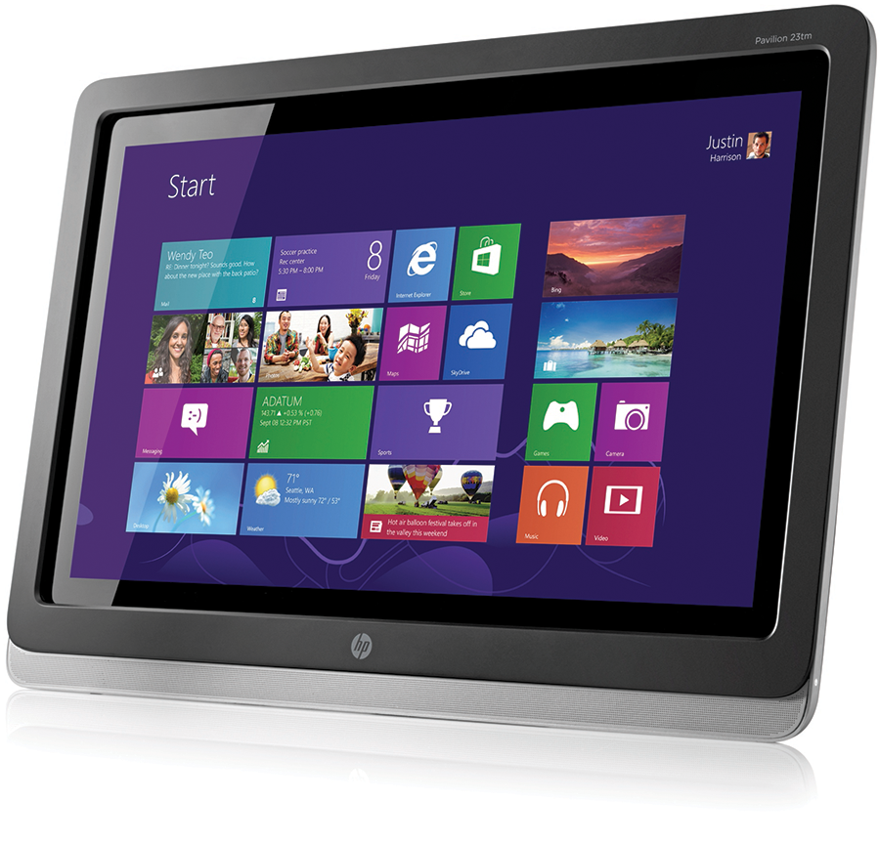

A bigger screen. More pixels. Navigation by touch.   
Get immersed in a stunning, fully reclining touchscreen experience that has you making the most out of your PC. It's about getting closer to your world so you can view your life in vivid detail—and have it all at your fingertips.

**Tap into fun.**

Add intuitive navigation to your PC experience. This large, Windows 8-certified touchscreen monitor is designed so you can tap, slide, and swipe your way to more games, videos, and photos—basically, more fun.1

**What’s your angle?**

Whatever you’re doing—playing, collaborating or working—the screen’s deep, easy-to-adjust 70-degree recline means you can do it comfortably.

Watch the way you want to: Leave it on the stand, or attach it to your favorite VESA swivel arm or wall mount.2 Flexibility, indeed.

**Bring on family movie night.**

Thanks to an HD3 screen, front-facing speaker, and 178-degree viewing angles, it’s a crisp, clear monitor you can see—and hear—from almost anywhere in the room.

**More ways to connect. More ways to watch.**

Whether you want HD3 gaming, big-screen sharing from small-screen devices, or crystal-clear visibility for everyday computing, one thing’s for sure, with DVI and HDMI inputs, you have more ways to connect with your source.

**Details, details, details.**

Full HD3 resolution, a 23-inch diagonal screen, and 10M:1 dynamic contrast ratio bring your digital world to life with precise detail. Think stunning, fluid, and incredibly crisp graphics that jump right off the screen.

**Control your environmental impact.**

Reduce power consumption and help lower your costs with an intelligent, energy-efficient design that is ENERGY STAR® qualified and EPEAT® Silver registered.4 The monitor also includes mercury-free display backlights and has a low halogen design.5

**Global reassurance.**

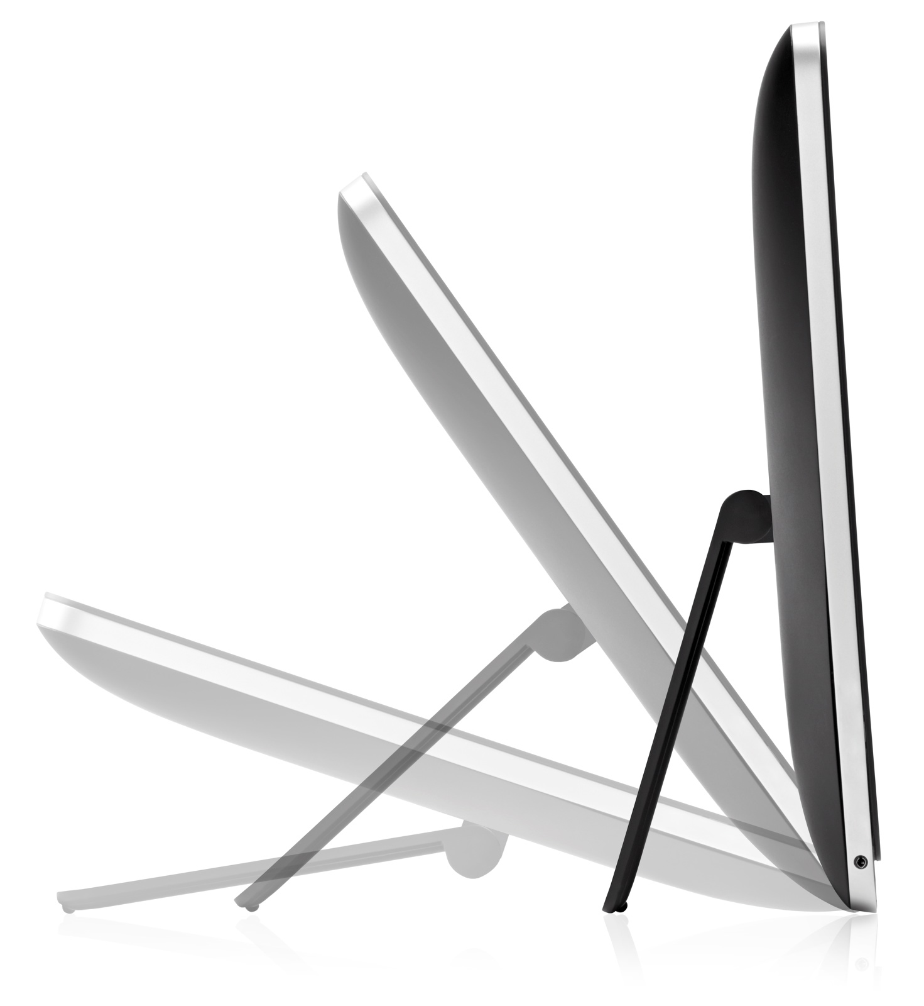Rest assured that your IT investment is supported by a one- or three-year standard limited warranty (varies by region).

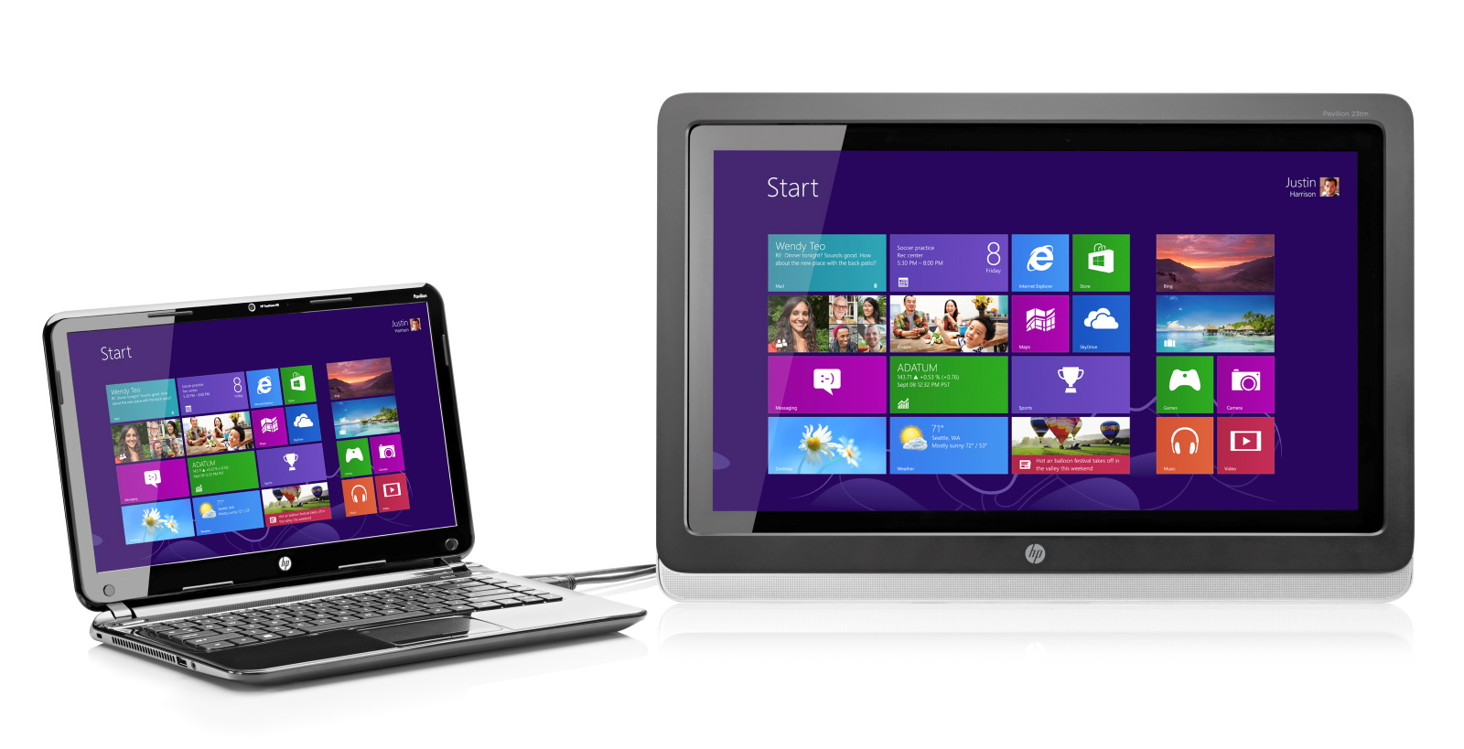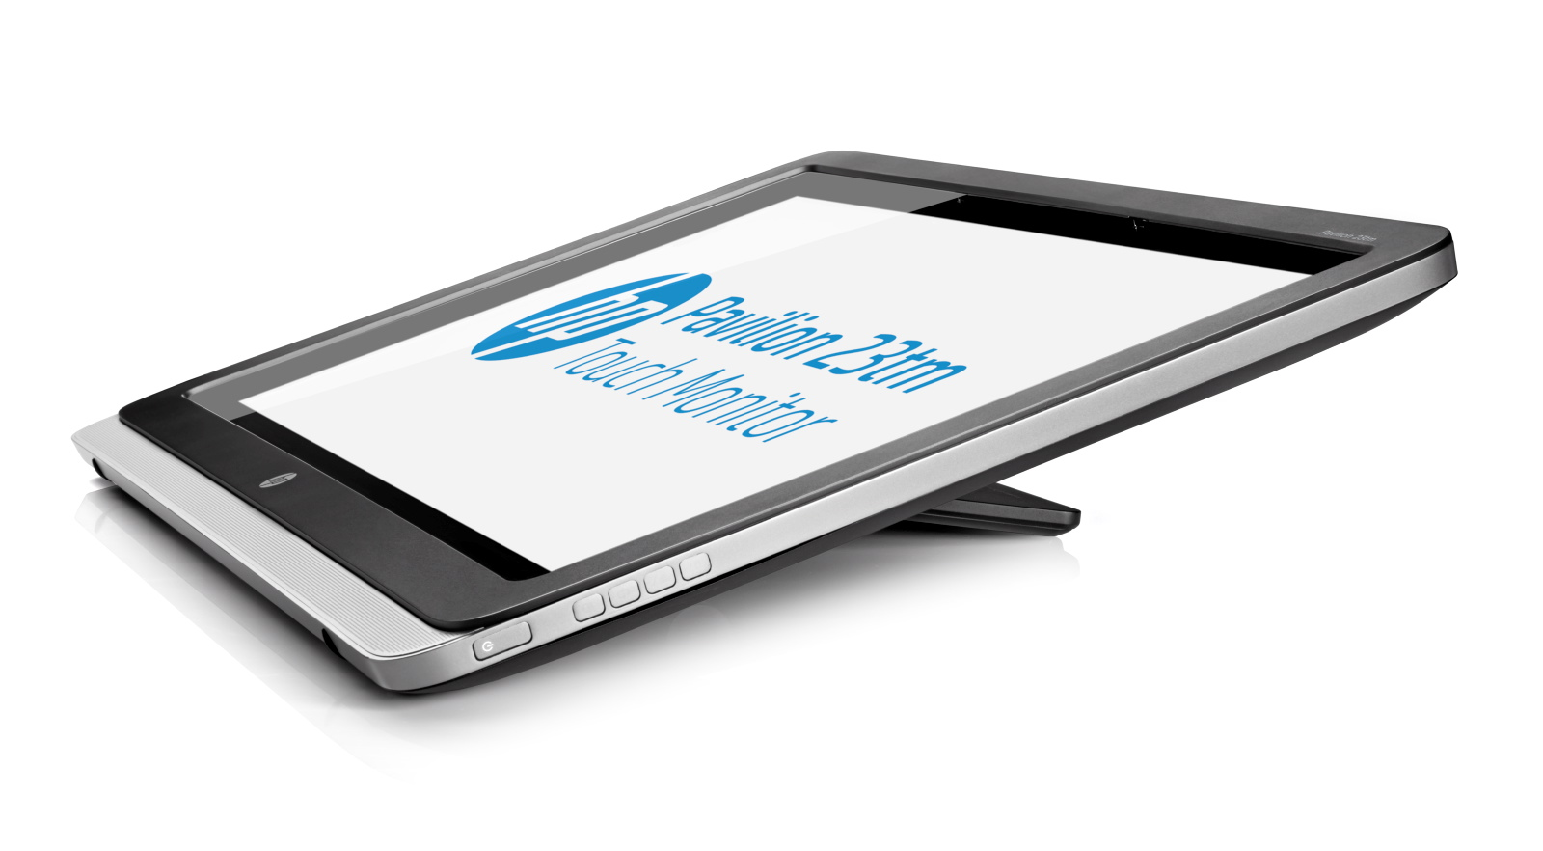

Shown connected to HP Pavilion Sleekbook , not included and sold separately.

**HP Pavilion 23tm Touch Monitor**

|  |  |
| --- | --- |
| **Part number** | E1L11AA |
| **Panel type** | Wide viewing angle with LED backlight |
| **Viewable image area** | 58,42 cm (23 in) widescreen; diagonally measured |
| **Viewing angle** | **Horizontal:** 178 degrees; **Vertical:** 178 degrees |
| **Brightness**6 | 220 cd/m2 |
| **Contrast ratio**6 | **Static:** 1000:1; **Dynamic:** 10,000,000:1 |
| **Response rate**6 | 7 ms (gray to gray with overdrive) |
| **Frequency** | **Horizontal**: 24 KHz-94 KHz; **Vertical**: 48 Hz-63 Hz |
| **Aspect ratio** | 16:9 |
| **Native resolution** | 1920 x 1080 @ 60 Hz |
| **Resolutions supported** | 1920 x 1080 @ 60 Hz, 1680 x 1050 @ 60 Hz, 1600 x 900 @ 60 Hz, 1440 x 900 @ 60 Hz, 1280 x 1024 @ 60 Hz, 1280 x 720 @ 60 Hz, 1024 x 768 @ 60 Hz, 800 x 600 @ 60 Hz, 720 x 400 @ 70 Hz, 640 x 480 @ 60 Hz |
| **Input signal** | (1) HDMI, (1) DVI-D (HDCP support on inputs) |
| **USB** | (1) USB port for touch functionality only |
| **Audio** | Built-in speakers, (1) audio out/headphone jack |
| **User controls** | Menu, Minus, Plus, OK and Power On/Off |
| **Power consumption** | **Maximum**: 33 W; **Typical**: 25 W; **Power saving**: 0.5 W |
| **Dimensions** (w x d x h) | **Unpacked**: 59,93 x 6,95 x 40,92 cm (23.6 x 2.7 x 16.1 in) |
| **Head only**: 59,93 x 4,05 x 40,92 cm (23.6 x 1.6 x 16.1 in) |
| **Packaged**: 68 x 13,9 x 50,7 cm (26.8 x 5.5 x 20 in) |
| **Weight** | **Unpacked**: 6,5 kg (14.3 lb); **Head only**: 5,5 kg (12.1 lb); **Packaged:** 8,5 kg (18.7 lb) |
| **Base features** | **Tilt:** +15° to + 70° vertical |
| **Environmental** | **Operating Temperature**: **5° to 35° C** (41° to 95° F); **Non-operating Temperature**: **-20° to 60° C** (-4° to 140° F) |
| **Operating Altitude: 0 – 5,000 m** (0 – 16,404 ft) |
| **Certification and compliance** | CB, CE, TUV-S, EAC, CUL, FCC, CSA, NOM, S-Mark, VCCI, PSB, ISC, CCC, BSMI, C-Tick, E-Standby, eK, CECP, TCO, Smartway Transportation Partnership (NA), Microsoft WHQL, Windows 8 Touch, ENERGY STAR®, EPEAT® Silver4 (select regions) |
| **Limited warranty** | Protected by HP, including a 1 year standard limited warranty. Certain restrictions and exclusions apply. |

1. Not all features are available in all editions of Windows 8. Systems may require upgraded and/or separately purchased hardware, drivers and/or software to take full advantage of Windows 8 functionality. See <http://www.microsoft.com>.

2. Options sold separately.

3. High-definition (HD) content required to view HD images.

4. EPEAT® SIlver registered models of this product are available where HP registers commercial display products. See www.epeat.net for registration status in your country.

5. External power supplies, power cords, cables and peripherals are not Low Halogen. Service parts obtained after purchase may not be Low Halogen.

6. All performance specifications represent the typical specifications provided by HP's component manufacturers; actual performance may vary either higher   
or lower.

HP_Blue_RGB.wmf

© Copyright 2013 Hewlett-Packard Development Company, L.P. The information contained herein is subject to change without notice. The only warranties for HP products and services are set forth in the express warranty statements accompanying such products and services. Nothing herein should be construed as constituting an additional warranty. HP shall not be liable for technical or editorial errors or omissions contained herein. July 2013