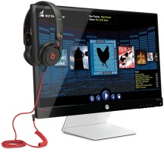HP_Blue_RGB.wmf

The display that defines the wow factor.

**HP Envy 23 23-Inch IPS Monitor with Beats Audio**

Bring your small screen content into the big leagues. Experience edge-to-edge presentation of all your games, movies, and content plus Beats Audio™ sound in a stunning IPS display.

**Super-size your small-screen content**

Connect to a wide range of devices and seamlessly stream content from your phone or tablet to your 23-inch diagonal display with one VGA and two HDMI inputs.

**Enjoy great color and views from almost any seat in the room**

Get great 178-degree viewing angles and stunning color integrity from In-Plane Switching (IPS) technology. Share videos, photos, games, and more with everyone in the room.

**Enjoy your sound the way it was meant to be heard**

Tune in to a total, immersive audiovisual experience with the Beats Audio™-integrated headphone jack. Quick keys deliver easy access to volume and mute controls.

**Massive views in a stylish and deceptively small footprint**

**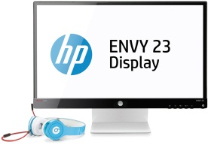**Bring your digital world to life with Full-HD resolution1 on a large 23-inch diagonal screen. Enjoy impressive video and graphics presentation from the 10M:1 dynamic contrast ratio.2

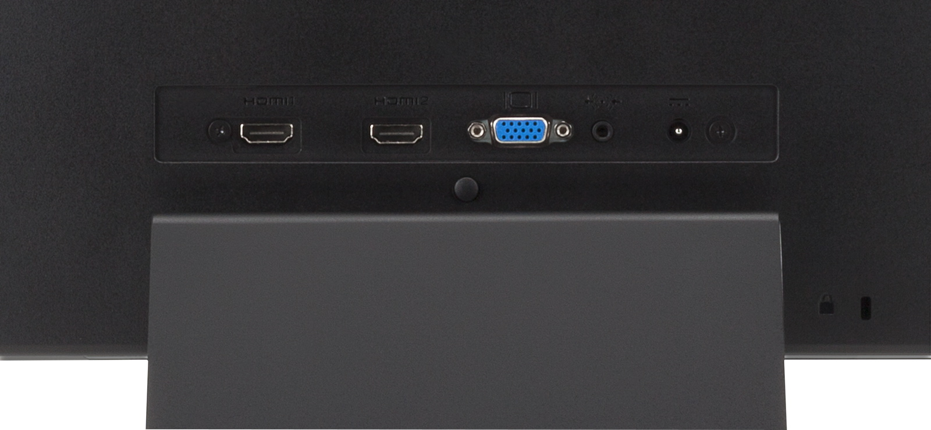

Get maximum, unobstructed views of your images and onscreen content from the edge-to-edge borderless screen. Reclaim your desk space with a narrow base that gives you more room to maneuver.

**Multi-task to your heart’s content**

Control power saving modes, save user settings for easy start up, and more with the step-by-step guide of the preinstalled HP My Display software.

Keep multiple application windows open at the same time and devote separate panels to watching videos or playing games, checking e-mails, and keeping track of social media streams.

**Rest easy**

Rely on the reassurance of HP’s award-winning service and support and a standard, 1-year limited warranty. Our Always On Technology portfolio of services and support is there when you need it.

**Be a better environmental consumer**

IPS technology helps you reduce power consumption costs vs. legacy LCD technology. Show off your environmental smarts with design elements such as mercury-free LED backlights, low halogen components,3 and arsenic-free display glass.

**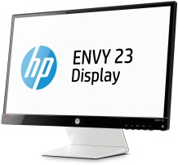**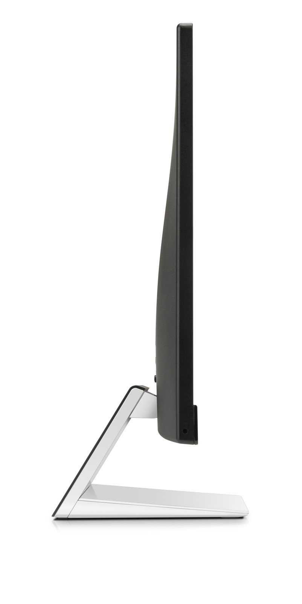

Shown with Beats™ headphones, not included and sold separately.

**HP Envy 23 23-Inch IPS Monitor with Beats Audio**

|  |  |
| --- | --- |
| **Part number** | E1K96AA |
| **Panel type** | IPS with LED backlight |
| **Viewable image area** | 58,42 cm (23 in) widescreen; diagonally measured |
| **Viewing angle** | **Horizontal:** 178 degrees; **Vertical:** 178 degrees |
| **Brightness**3 | 250 cd/m2 |
| **Contrast ratio**3 | **Static:** 1000:1; **Dynamic:** 10,000,000:1 |
| **Response rate**3 | 7 ms (gray to gray) |
| **Frequency** | **Horizontal**: 24 KHz-94 KHz; **Vertical**: 50 Hz-76 Hz |
| **Aspect ratio** | 16:9 |
| **Native resolution** | 1920 x 1080 @ 60 Hz |
| **Resolutions supported** | 1920 x 1080 @ 60 Hz, 1680 x 1050 @ 60 Hz, 1600 x 900 @ 60 Hz, 1440 x 900 @ 60 Hz, 1280 x 1024 @ 60 Hz, 1280 x 720 @ 60 Hz, 1024 x 768 @ 60 Hz, 800 x 600 @ 60 Hz, 720 x 400 @ 70 Hz, 640 x 480 @ 60 Hz |
| **Input signal** | (1) VGA, (2) HDMI (HDCP support) |
| **Audio** | (1) audio out/headphone jack with Beats Audio™ output, (1) audio in jack |
| **User controls** | Menu, Auto, Minus “-“, Plus “+”, OK/Mute, Power button |
| **Power consumption** | **Maximum**: 28 W; **Typical**: 26.5 W; **Power saving**: <0.5 W |
| **Dimensions** (w x d x h) | **Unpacked**: 53,2 x 17,37 x 40,46 cm (20.94 x 6.83 x 15.92 in) |
| **Head only**: 53,2 x 3,5 x 33 cm (20.94 x 1.38 x 12.99 in) |
| **Packaged**: 60,5 x 13 x 41,5 cm (23.82 x 5.14 x 16.34 in) |
| **Weight** | **Unpacked**: 3,53 kg (7.78 lb); **Head only**: 2,81 kg (6.19 lb); **Packaged:** 5,45 kg (12.01 lb) |
| **Base features** | **Tilt:** -5° to + 25° vertical |
| **Environmental** | **Operating**: **5° to 35° C** (41° to 95° F); **Non-operating**: **-20° to 60° C** (-4° to 140° F) |
| **Certification and compliance** | CB, CE, FCC marking, ES6.0, ErP, CSA/C-UL/C-ETL Mark, UL/CSA-NTRL/ETL-NRTL Mark, ICES, Argentina S-Mark, Japan VCCI, CCC, China CEL Grade 1, Taiwan BSMI,Bauart, CECP, ISO9241-307, GOST 25861, HRN N N0.201, GOST R 50377-1992, GOST 25861, EEI certificate, IS 1121, SASO, SABS IEC 60950-1, NOM-019-SCFI-1998, KC Mark, KCC Mark, PSB mark, ISC mark, C-Tick, Smartway Transportation Partnership (NA), Microsoft WHQL, ENERGY STAR®, EPEAT® Silver4 (select regions) |
| **Limited warranty** | Protected by HP, including a 1 year standard limited warranty. Certain restrictions and exclusions apply. |

1. High-definition (HD) content required to view HD images.

2. Internet service required, and not included.

3. All performance specifications represent the typical specifications provided by HP's component manufacturers; actual performance may vary either higher   
or lower.

4. EPEAT® Silver registered models of this product are available where HP registers commercial display products. See www.epeat.net for registration status in your country.

HP_Blue_RGB.wmf

© Copyright 2013 Hewlett-Packard Development Company, L.P. The information contained herein is subject to change without notice. The only warranties for HP products and services are set forth in the express warranty statements accompanying such products and services. Nothing herein should be construed as constituting an additional warranty. HP shall not be liable for technical or editorial errors or omissions contained herein. July 2013